- Regression

- Activation Functions
- Linear (No Activation Functions):
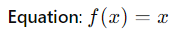
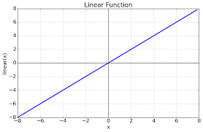
  - When Used: Standard regression problems where the output is a real number.
- Tanh:
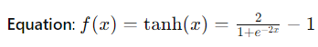
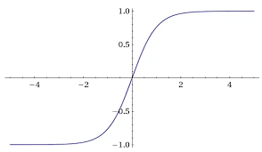
  - When Used: Regression problems where the output needs to be scaled between -1 and 1.
- ReLU:
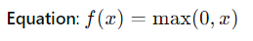
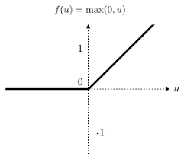
  - When Used: Specific cases of regression problems where non-linearity is needed in the output.
- Leaky ReLU:
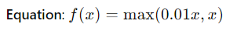
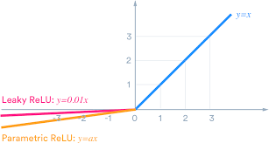
  - When Used: To avoid the "dying ReLU" problem in regression tasks.

- Cost Functions
- Mean Squared Error (MSE):
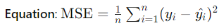
  - When Used: Standard regression problems to minimize the squared difference between predicted and actual values.
- Mean Absolute Error (MAE):
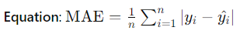
  - When Used: Regression problems to minimize the absolute difference between predicted and actual values.
- Huber Loss:
  - Equation:
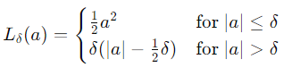
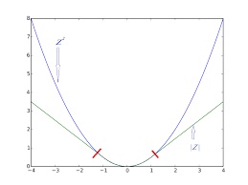
  - When Used: Regression problems to be less sensitive to outliers than MSE.
- Examples
- Predicting house prices
- Predicting stock prices
- Predicting normalized values that can take both positive and negative values

- Binary Classification
- Activation Functions
- Sigmoid:
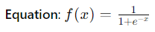
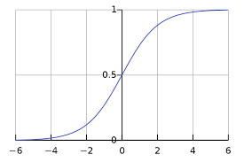
  - When Used: Binary classification problems where the output is a probability between 0 and 1.
- Cost Functions
- Binary Cross-Entropy (Log Loss):
  - When Used: Binary classification problems to measure the performance of a classification model whose output is a probability value.
- Hinge Loss:
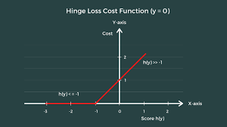
  - When Used: Binary classification problems, often used with Support Vector Machines (SVMs).
- Examples
- Predicting whether an email is spam or not
- Predicting whether a customer will buy a product (yes/no)
- Multi-Class Classification
- Activation Functions
- SoftMax:
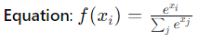
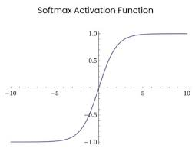
  - When Used: Multi-class classification problems where the output is a probability distribution over multiple class.
- Cost Functions
- Categorical Cross-Entropy:
  - When Used: Multi-class classification problems to measure the performance of a classification model whose output is a probability value over multiple classes.
- Sparse Categorical Cross-Entropy:
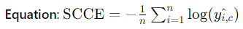
  - When Used: Multi-class classification problems when labels are integers rather than one-hot encoded vectors.
- Examples
- Classifying images of handwritten digits into one of 10 classes (0-9)
- Classifying types of animals in an image dataset (e.g., cat, dog, horse)

- Summary
- Regression:
  - Activation Functions: Linear, Tanh, ReLU, Leaky ReLU
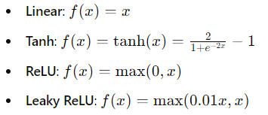
  - Cost Functions: Mean Squared Error (MSE), Mean Absolute Error (MAE), Huber Loss
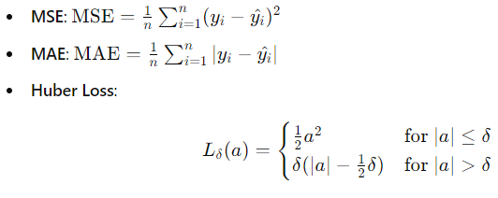
- Binary Classification:
  - Activation Function: Sigmoid
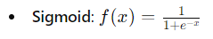
  - Cost Functions: Binary Cross-Entropy, Hinge Loss
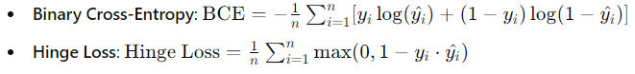

- Multi-Class Classification:
  - Activation Function: Softmax
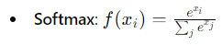
  - Cost Functions: Categorical Cross-Entropy, Sparse Categorical Cross-Entropy
